**Daniel Mungai Ndegwa**



**Name: Daniel Mungai Ndegwa**

**ID Number: 29785081**

**Birth Date: 5th January 1992**

**P. O Box: 3917-01002**

**County: Kiambu**

**City: Thika, Kenya**

**TEL: +254713946813**

**Height: 5.7m**

**Weight:63kg**

**Email: Mungaindegwa@gmail.com,**

# SKILLS

* Competencies in Data analysis with R-Programming and SPSS
* Manipulation of fisheries Data modelling
* GIS-ArcGIS Mapping Techniques and Remote Sensing
* Habitat characterization and surveying
* Scientific academic and online writing and reporting- TCC Trained
* Acquired skills in data analysis, referencing techniques using Mendeley and Zotero

# EXPERIENCE

Kenya Marine and Fisheries Research Institute, Kisumu County – *Resident* Researcher

September 2018 - Present

* + Data Analysis and Modelling
  + Fisheries interactions Modelling
  + Fisheries-Socio-economics and value chain
  + Fisheries-water-food-Nexus study

**Kisii University, Kisii County** *— Part-time Tutor*

May 2018 - PRESENT

* Fish Nutrition
* Oceanography
* Research Methods

**Egerton University, Njoro, Nakuru County** *— Laboratory Assistant*

September 2016 - May 2017

* Zoology and Botany Lab
* Aquatic Science Lab

**Nairobi City Water and Sewerage Company, Nairobi** *— Industrial Attachment*

**June 2015 - August 2015**

* Remote sensing and GIS in water quality and
* water level Sensing
* Quality Control and Quality Assurance of Chemicals
* Microbiology quality determination
* Water Treatment
* Determination of heavy and light metals in water

**Kiambu County Agriculture Department, Thika** *— Data analyst Clerk*

December 2013 - February 2014

* Data entry for Kiambu farmers
* Baseline Survey for Kiambu county farmers
* Data presentation and interpretation

# EDUCATION

**Data-Camp – Online data Science camp and training**

Data wrangling and visualization with R-Programming

Data Analysis and visualization with SPSS

**Kisii University, Kisii** *— Master of Science Degree in Fisheries*

September 2017 - Present, Kisii

Master of science Degree in fisheries management. Involves blue economy in the developing countries, Fish population Dynamics, Stock Assessments, Ecological Modeling.

**Egerton University, Njoro, Nakuru** *— Bachelor of Science Degree*

September 2012 – December 2016

Bachelor of science Degree in applied aquatic sciences. Involved laws of the sea and inland waters, blue economy, fishery technology, oceanography, Fishery technology, mariculture, aquaculture, aquatic resource management.

**Kairi Boys Secondary School, Thika** *— KCSE 2011*

January 2008 – December 2011

Kenya certificate of Secondary Education B+

# **AWARDS**

Participation in a Mendeley Training

Participation in TCC- Academic Writing and Publishing Course

Participation in a climate change training in Nairobi University

Hobbies and interests

Data wrangling, analysis and visualization with programming statistical software

Data modelling

Member of the tidy Tuesday data analysis, wrangling and visualization community, Nairobi-R, R-ladies and Africa-R.

Machine Learning and AI

# **Referees**

Major (Dr) Wakaba Wangaka

Wangakaws@gmail.com

Tell: +254722745791

Nairobi

Dr. Reuben Omondi (PhD)

Department of Aquatic and Fishery Science

Kisii University

Tell: +254729009711

Dr. Chrispine Nyamweya

Kenya Marine and Fisheries Research Institute

P.O. Box 1881, Kisumu Tel: +254724504636

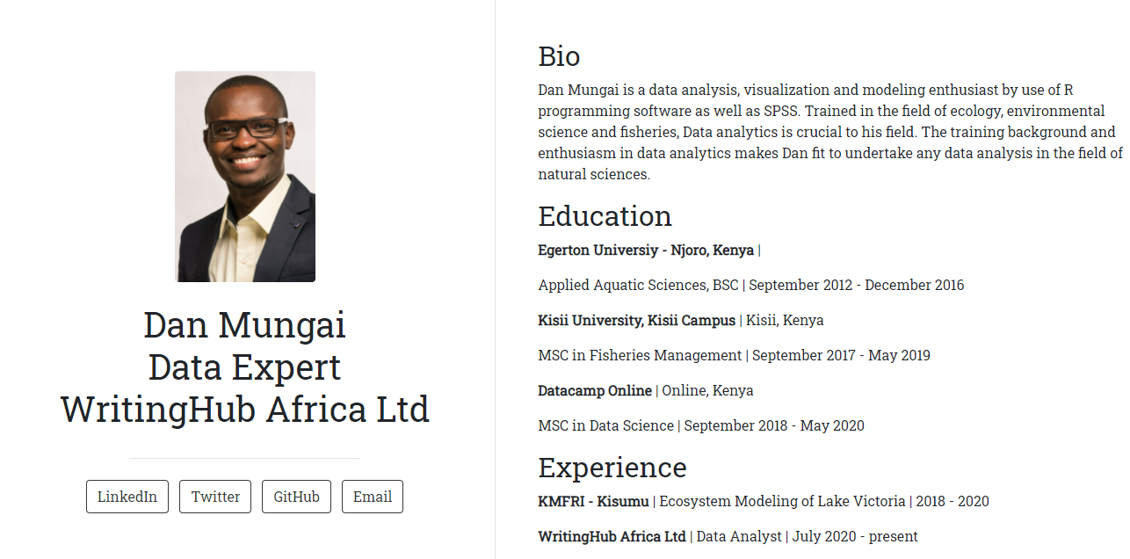

[Dan Mungai <br> Data Expert <br> WritingHub Africa Ltd (elegant-hoover-26ef35.netlify.app)](https://elegant-hoover-26ef35.netlify.app/)